DIGITAL HEALTH ECOSYSTEM WALES
Software Development Kit: Reference Data

Revision History
Date | Version | Description | Author
29th June 2018 | 0.1d | Initial draft | Tim Dawe (Senior Product Specialist)
09th July 2018 | 0.2d | Added introduction and minor changes to formatting, layout and writing style. | Geoff Norton (Software Development Manager)
10th July 2018 | 0.3d | After discussing with the NWIS Communications Team, I’ve added instruction on how to receive feedback (page 4.) | Geoff Norton (Software Development Manager)
11th July | 1.0 | Technical Review – removed multiple identifiers example under Use Case 4. Searching via browser isn’t supported using our current server implementation. | Tim Dawe

Table of Contents
1. Introduction 4
1.1 Purpose and Audience 4
1.2 Comments and Suggestions 4
1.3 Notes to the Reader 4
1.4 Availability of Services 4
2. Implementation 5
2.1 Relationships & Filtering 5
2.2 Organisation Types 5
2.3 Restriction placed upon the number of results returned 5
2.4 Language 5
3. Use Cases and example queries 7
3.1 Use Case1: Retrieve a list of organisations 7
3.2 Use Case 2: Retrieve a list of organisations of a specific type 7
3.3 Use Case 3: Retrieve a specific organisation using its FHIR id 7
3.4 Use Case 4: Retrieve a specific organisation using its Organisational Data Services (ODS) National Code 7
3.5 Use Case 5: Retrieve a list of General Practices in a specific Health Board 8
3.6 Use Case 6: Retrieve a list of Practitioners 8
3.7 Use Case 7: Retrieve a specific Practitioner by National Code 8
3.8 Use Case 8: Retrieve a specific organisation and the related practitioners 8

Introduction

Purpose and Audience
This document, the second in a series published under the umbrella term – Software Development Kit [SDK], describes the second Application Programming Interface (API) built by the NHS Wales Informatics Service. It provides guidance to those intending to implement the API.
Departing from our original intention of developing the SDK as a single document, we now publish each API guide separately on the NHS Wales Informatics service website. At the time of writing, these guides are available from http://www.wales.nhs.uk/nwis/page/95445.

Comments and Suggestions
Our approach is to develop incrementally, publishing API test cases and listening and adapting to responses and feedback. This applies not only to the API themselves but also the accompanying documentation. If you have any comments, suggestions or feedback regarding the API and this associated documentation please send it to NHSWales.Tech@wales.nhs.uk.

Notes to the Reader
This is a technical document and expects the reader to have a basic familiarity with the HL7 FHIR and REST API specifications – a full description of the FHIR specification is available from https://www.hl7.org/.

Availability of Services
The API this document describes is hosted on a test platform. It must not be used by any production or ‘live’ system or service. This API provides is test data and must not be considered for production services or ‘live’ use.
The service may be unavailable for maintenance.

Implementation
The Reference Data API is based on the HL7 FHIR specification. A full description of the FHIR specification is available at https://www.hl7.org/. The API is located at https://dhew.wales.nhs.uk/hapi-fhir-jpaserver-example/.
While the API implements the full FHIR specification, it contains only representative data. As outlined earlier in this document this data is therefore not necessarily current, accurate or complete. The API provides representative data for the following reference data types (indicated below with their associated FHIR Resource Type:
Reference Data Type | FHIR Resource Type
Health Boards | Organisation
General Practices | Organisation
General Practitioners | Practitioner
Practitioner Roles | PractitionerRole

Relationships & Filtering
- The API populates the partOf element of the General Practice with the FHIR Id of the Heath Board and uses it to map the parent/ child relationship between Health Board and General Practice.
- The API uses the PractitionerRole resource to map the relationship between General Practitioners and General Practice.

Organisation Types
Organisation FHIR resource types are coded as follows:
- HB
- GPPractice

Restriction placed upon the number of results returned
The API limits the number of results returned to 10.

Language
The API uses extension definitions to include both organisation names and addresses in both Welsh and English (where the data is available) in the returned dataset. Figure one, on the following page, shows a returned JSON dataset, which illustrates how these definitions are used.
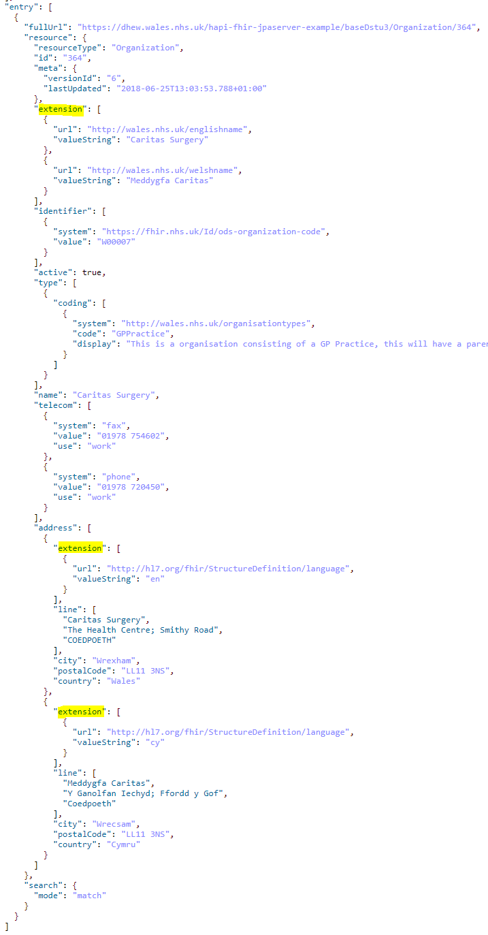
Figure 1: Use of Extension Definitions for Welsh and English Names and Addresses

Use Cases and example queries
The remainder of this document describes the use cases the API satisfies. We demonstrate these by constructing example URLs as one would do if viewing the search results within a web browser.
However, implementers may also use the search facility provided by the FHIR server itself or develop client applications. More information on how to develop client applications using both Java and .NET is available from http://hapifhir.io/ and http://ewoutkramer.github.io/fhir-net-api/
The base URL for REST requests is: https://dhew.wales.nhs.uk/hapi-fhir-jpaserver-example/baseDstu3/. To satisfy each use case you simply append the appropriate query to this base URL.

Use Case1: Retrieve a list of organisations
Query: Organization
Example: https://dhew.wales.nhs.uk/hapi-fhir-jpaserver-example/baseDstu3/Organization

Use Case 2: Retrieve a list of organisations of a specific type
Query: Organization?type=<Insert Type Code>
Examples:
https://dhew.wales.nhs.uk/hapi-fhir-jpaserver-example/baseDstu3/Organization?type=HB
https://dhew.wales.nhs.uk/hapi-fhir-jpaserver-example/baseDstu3/Organization?type=GPPractice

Use Case 3: Retrieve a specific organisation using its FHIR id
Query: Organization/<Insert FHIR ID>
Example: https://dhew.wales.nhs.uk/hapi-fhir-jpaserver-example/baseDstu3/Organization/145

Use Case 4: Retrieve a specific organisation using its Organisational Data Services (ODS) National Code
Query: Organization?identifier=<Insert National Code>
Example (Health Board):
https://dhew.wales.nhs.uk/hapi-fhir-jpaserver-example/baseDstu3/Organization?identifier=7A1
Example (General Practice):
https://dhew.wales.nhs.uk/hapi-fhir-jpaserver-example/baseDstu3/Organization?identifier=W00143

Use Case 5: Retrieve a list of General Practices in a specific Health Board
Step #1: Obtain the FIHR Id for the Health Board.
Query: Organization?identifier=7A1
Example:
https://dhew.wales.nhs.uk/hapi-fhir-jpaserver-example/baseDstu3/Organization?identifier=7A1
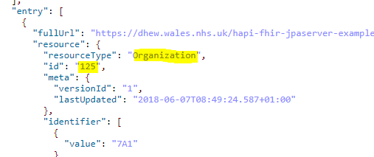
Figure 2: Step #1 - Obtain the FHIR Id
Step #2: Query again for the Practices:
Query: Organization?type=GPPractice&partof=Organization/125
Example:
https://dhew.wales.nhs.uk/hapi-fhir-jpaserver-example/baseDstu3/Organization?type=GPPractice&partof=Organization/125

Use Case 6: Retrieve a list of Practitioners
Query: Practitioner
Example: https://dhew.wales.nhs.uk/hapi-fhir-jpaserver-example/baseDstu3/Practitioner

Use Case 7: Retrieve a specific Practitioner by National Code
Query: Practitioner?identifier=<Insert National Code>
Example:
https://dhew.wales.nhs.uk/hapi-fhir-jpaserver-example/baseDstu3/Practitioner?identifier=G8433963

Use Case 8: Retrieve a specific organisation and the related practitioners
In this case a General Practice and its General Practitioners
Query: PractitionerRole? include=PractitionerRole:practitioner&organization:Organization=<Insert FHIR ID>
Example:
https://dhew.wales.nhs.uk/hapi-fhir-jpaserver-example/baseDstu3/PractitionerRole?_include=PractitionerRole:practitioner&organization:Organization=430

Please note the first API Guide in the series has is now rebranded as ‘Software Development Kit - Patient Demographics API Guide’
Please note this email address is primarily to receive your comments and suggestions around the technical implementation and documentation and not for technical support. However, we shall endeavour to answer any queries where we can.
Please note the list is not exhaustive but the reader will quickly determine additional use cases by reading the documentation and navigating directly to API instance (i.e. the FHIR server UI) using a browser.
Building search queries through the FHIR server UI is a good way of understanding how to construct URLs and client code as it provides both together with the returned results!

