DIGITAL HEALTH ECOSYSTEM WALES
Software Development Kit – Diagnostic Observations and Reports API Guide

Revision History
Date | Version | Description | Author
22nd January 2019 | 0.1d | Initial draft | Geoff Norton [Software Development Manager]
25 January 2019 | 0.1 | Full draft | Geoff Norton [Software Development Manager]

Table of Contents
1. Introduction 4
1.1 Purpose and Audience 4
1.2 Comments and Suggestions 4
1.3 Notes to the Reader 4
1.4 Availability of Services 4
2. Implementation 5
3. Use Cases and example queries 5
3.1 Overview 5
3.2 Use Case 1: Retrieve a list of Patient’s Test Results 6
3.3 Use Case 2: View a Patient’s Test Result 6
3.4 Use Case 3: Chart a Patient’s Test Result Data 6

Introduction

Purpose and Audience
This document, the second in a series published under the umbrella term – Software Development Kit [SDK], describes the second Application Programming Interface (API) built by the NHS Wales Informatics Service. It provides guidance to those intending to implement the API.
Departing from our original intention of developing the SDK as a single document, we now publish each API guide separately on the NHS Wales Informatics service website. At the time of writing, these guides are available from http://www.wales.nhs.uk/nwis/page/95445.

Comments and Suggestions
Our approach is to develop incrementally, publishing API test cases and listening and adapting to responses and feedback. This applies not only to the API themselves but also the accompanying documentation. If you have any comments, suggestions or feedback regarding the API and this associated documentation please send it to NHSWales.Tech@wales.nhs.uk.

Notes to the Reader
This is a technical document and expects the reader to have a basic familiarity with the HL7 FHIR and REST API specifications – a full description of the FHIR specification is available from https://www.hl7.org/.

Availability of Services
The API this document describes is hosted on a test platform. It must not be used by any production or ‘live’ system or service. This API provides is test data and must not be considered for production services or ‘live’ use.
The service may be unavailable for maintenance.

Implementation
The API is based on the HL7 FHIR specification. A full description of the FHIR specification is available at https://www.hl7.org/. The API is located at https://dhew.wales.nhs.uk/hapi-fhir-jpaserver-example/.
While the API implements the full FHIR specification, it contains only fictious data. The API provides representative data for the following reference data types (indicated below with their associated FHIR Resource Type:
Reference Data Type | FHIR Resource Type
Diagnostic Report | DiagnosticReport
Diagnostic Observation | Observation

Use Cases and example queries
Software Development Kit – Patient Demograohic Data API Guide.

Overview
The remainder of this document describes the use cases the API satisfies. We demonstrate these by constructing example URLs as one would do if viewing the search results within a web browser.
This API demonstrates the following basic use cases. These use cases pre-suppose the execution of separate uses described in Retrieve patient records by performing a demongraphic search :-
- Retrieve list of test results for patient
- View test result
- Chart test result data
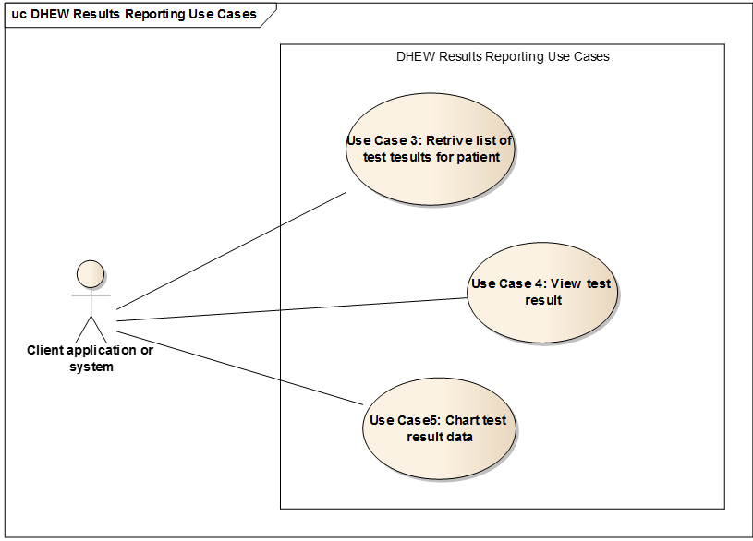
Figure 1 Diagnostic Observations and Results use cases

Use Case 1: Retrieve a list of Patient’s Test Results
The C# code sample below illustrates how to retrieve a patient’s test results by the patient’s NHS number . This example requires Hl7.Fhir.Specification.STU3 NuGet package, which provides client tools and functionality for working with the FHIR specification. To install the NuGet package to your .NET project, enter the following text in the Package Manger Console:
PM> Install-Package Hl7.Fhir.Specification.STU3

Documentation for this package is available at http://ewoutkramer.github.io/fhir-net-api/.
The code sample below is taken form a .NET Framework Console App.
using System;
using Hl7.Fhir.Model;
using Hl7.Fhir.Rest;

namespace DHEW_DemoFhirConsole
{
class Program
{
static void Main(string[] args)
{
FhirClient client = new FhirClient("https://dhew.wales.nhs.uk/hapi-fhir-jpaserver-example/baseDstu3");

var patientId = "3795624164";
var nhsNoSystemIdentifier = "https://fhir.nhs.uk/Id/nhs-number";

// find a patient record based on NHS number
Bundle reports = client.Search<DiagnosticReport>(new string[]
{
$"patient.identifier={nhsNoSystemIdentifier}|{patientId}"
});

Console.WriteLine($"There are {reports.Total} diagnostic reports for the patient");
}
}
}

Alternatively, to perform the same search via a URL and to view the search results within a web browser, enter the following URL:
https://dhew.wales.nhs.uk/hapi-fhir-jpaserver-example/baseDstu3/DiagnosticReport?patient.identifier=https://fhir.nhs.uk/Id/nhs-number%7C3795624164&_format=html/xml

Use Case 2: View a Patient’s Test Result
The C# code sample below illustrates how to view a patient’s test result using a DiagnosticReport id, which will have been retrieved using the previous call.
DiagnosticReport diagnosticReport = client.Read<DiagnosticReport>("DiagnosticReport/11011");
Console.WriteLine(diagnosticReport.Text.Div);

This code writes a text summary of the resource to the console:
Laboratory number: 900012453904
Result/Report origin: Organisation: 7A4 - Department: BSC

Urea and Electrolytes [Plasma] (Authorised[A])
Sodium 140 mmol/L 133-146
Potassium (Plasma) 4.0 mmol/L 3.5-5.0
Urea 4.0 mmol/L 2.5-7.8
Creatinine 175 umol/L 58-110 H

eGFR and electrolytes (Plasma) (Authorised[A])
Sodium 140 mmol/L 133-146
Potassium (Plasma) 4.0 mmol/L 3.5-5.0
Creatinine 175 umol/L 58-110 H
Estimated GFR 38 ml/min/1.73m2

Creatinine [Plasma] (Authorised[A])
Creatinine 175 umol/L 58-110 H

Estimated GFR (Plasma) (Authorised[A])
Creatinine 175 umol/L 58-110 H
Estimated GFR 38 ml/min/1.73m2
This is an estimate of GFR and is not valid in situations of rapidly changing serum creatinine. See www.renal.org for further information on this and other limitations of its use.

Urea and Electrolytes [Plasma]: Authorised by CAV: Rachel Brixey-McCann on 22/10/2018 at 12:40
eGFR and electrolytes (Plasma): Authorised by CAV: Rachel Brixey-McCann on 22/10/2018 at 12:40
Creatinine [Plasma]: Authorised by CAV: Rachel Brixey-McCann on 22/10/2018 at 12:40
Estimated GFR (Plasma): Authorised by CAV: Rachel Brixey-McCann on 22/10/2018 at 12:39

The report contains four results (Urea and Electrolytes, eGFR and electrolytes (Plasma), Creatinine [Plasma], Estimated GFR (Plasma). These results are expressed as FHIR Observation resources, which in turn reference other FHIR Observation resouces that represent the test result items such as Sodium, Potassium, Urea, and Creatinine. These 'nested' resources contain the actual result values e.g. 'Sodium 140 mmol/L'
The diagnosticReport.Results field contains references to the four 'top level' results. For simplicity, all the observations are included as 'contained' resources within the DiagnosticReport FHIR resource - see the notes on contained resources (URL:https://hl7.org/fhir/STU3/references.html#contained).
This structure for a DiagnosticReport conaining nested Observations contained within the report is based on this example from the FHIR specification (URL: http://hl7.org/fhir/STU3/diagnosticreport-example-ghp.html).

Alternatively, the same test result can be retrieved in a browser via the following URL:
https://dhew.wales.nhs.uk/hapi-fhir-jpaserver-example/baseDstu3/DiagnosticReport/11011?_format=xml&_pretty=true

Use Case 3: Chart a Patient’s Test Result Data
The C# code sample below illustrates how to chart a patient’s test result data. In this example, we’ll retrieve all the sodim results for the patient using the code NA (this code is Wales Result Report Service code, and this system is identified by the URI: https://fhir.nhs.uk/Id/nhs-number.)
var observationCode = "NA";
var wrrsSystemIdentifier = "http://wrrs.wales.nhs.uk";

Bundle sodiumObservations = client.Search<Observation>(new string[]
{
$"patient.identifier={nhsNoSystemIdentifier}|{patientId}",
$"code={wrrsSystemIdentifier}|{observationCode}"
});

foreach (var entry in sodiumObservations.Entry)
{
Observation sodiumObservation = entry.Resource as Observation;
Console.WriteLine(((Quantity)sodiumObservation?.Value)?.ValueElement.Value);
}

This code simply writes the patient’s sodium result values to the console, but these values values can be taken along with the result date to a graph for display to the user.
Alternatively, to perform the same search via a URL and to view the search results within a web browser, enter the following URL:
https://dhew.wales.nhs.uk/hapi-fhir-jpaserver-example/baseDstu3/Observation?patient.identifier=https://fhir.nhs.uk/Id/nhs-number%7C3795624164&code=http://wrrs.wales.nhs.uk%7CNA&_format=html/xml

Please note the first API Guide in the series has is now rebranded as ‘Software Development Kit - Patient Demographics API Guide’
Please note this email address is primarily to receive your comments and suggestions around the technical implementation and documentation and not for technical support. However, we shall endeavour to answer any queries where we can.
Please note the list is not exhaustive but the reader will quickly determine additional use cases by reading the documentation and navigating directly to API instance (i.e. the FHIR server UI) using a browser.

